# Read the questions below and match the underlined words and phrases to their meanings.

* 1. When was the last time you didn’t like someone new, but you couldn’t put your finger on why?
  2. If you were to hire an employee, would you ever follow your gut feeling?
  3. Do you think that recruiters are aware of their possible bias?

MEANINGS:

1. an attitude that you have that makes you treat someone in a way that is unfair or different from the way you treat other people
2. a feeling that you are certain is right, although you can give no good reason why
3. discover or understand the reason for something

# Answer the questions in the previous exercise.

1. **Complete the table with nouns, adjectives and verbs.**

|  |  |  |
| --- | --- | --- |
| NOUN | ADJECTIVE | VERB |
| recruitment / recruiter | (un)recruitable1 | recruit |
| ………………… | assessable | ………………… |
| assumption | ………………… | ………………… |
| ………………… | (un)conscious |  |
| ………………… | (un)………………… | perceive |
| desire | (un)………………… | ………………… |
| ………………… |  | appear |
| ………………… / judge | (non-)………………… | judge |

1 It’s a recruitment jargon word meaning ‘able to be recruited’ or ‘suitable for recruitment’ (not included in some dictionaries).

# Before watching a TED Talk, guess the answer to the following question.

* 1. How much time on average does it take a recruiter to review a resume?
     + 6 seconds
     + 90 seconds
     + 3 minutes
     + 6 minutes

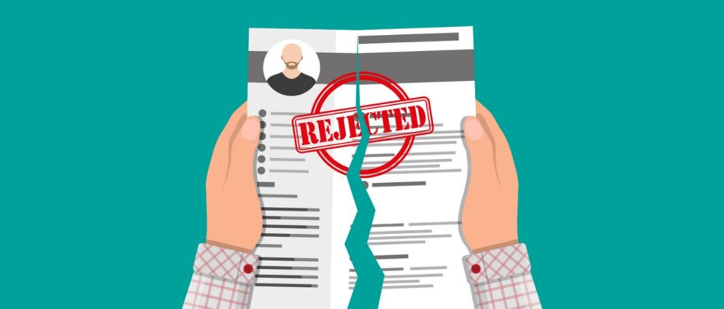

# Watch the [video](https://youtu.be/QCFb4BiDDcE) (to 05:25) [https://youtu.be/QCFb4BiDDcE] and note down why a recruiter might reject a candidate’s resume (put it in the “no” pile).

* …………………………………………………………………………………………
* …………………………………………………………………………………………
* …………………………………………………………………………………………
* …………………………………………………………………………………………
* …………………………………………………………………………………………
* …………………………………………………………………………………………

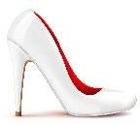

**CULTURE CORNER**

white pumps

Click to learn about the old-fashioned "[you can't wear white after Labor Day](https://www.southernliving.com/labor-day/why-cant-you-wear-white-after-labor-day)" rule in the USA.

# Complete the questions by transforming the words in capitals.

* 1. Should have the right to check your social media profiles?

RECRUIT

* 1. What aspects should never be during the hiring process?

ASSESS

* 1. What can we do in the recruitment process to not be biased against somebody’s ? APPEAR
  2. Have you ever thought about how your affects how you judge

others? PERCEIVE

* 1. Do you remember a situation when you made an about

somebody which proved to be wrong? ASSUME

* 1. How can we fight against bias to make more objective

decisions? CONSCIOUSNESS

# Discuss the questions from ex. 6.

1. **Read the short description below and discuss how you might perceive the person presented in the description.**

*Imagine a woman walking onto the TED Talk stage. She’s wearing a bright red, white polka dot dress, purple hair, she’s wearing lovely white pumps and tattoos.*

# Watch the second part of the [TED Talk](https://youtu.be/QCFb4BiDDcE?t=335) (from 05:25) and answer the questions.

* 1. What does unconscious bias lead to in decision-making?

…………………………………………………………………………………………

* 1. What did the speaker discover she is biased against?

…………………………………………………………………………………………

* 1. How does asking yourself ‘so what’ help you fight with unconscious bias?

…………………………………………………………………………………………

# Look at the sentences from the video and choose synonyms of the words and phrases in bold.

* 1. It's **inevitable** that we will all be wrongly judged and perceived by someone else's unconscious bias.
  2. I **dug deep into**2 self-awareness and (…) I wrote down my assumptions, judgements, perceptions, and I had a huge discovery.
  3. The **brutal** discovery [was that] I did have unconscious bias. We all have unconscious bias all the time.
  4. Twenty years of this unconscious bias really **drained** me. It really made me feel that maybe I didn't belong in recruiting anymore.

SYNONYMS:

1. exhaust, tire out
2. unavoidable, certain
3. unpleasant, harsh
4. investigate thoroughly, make a great effort

# Create three sentences with the words and phrases from ex. 10.

………………………………………………………………………………………………

………………………………………………………………………………………………

………………………………………………………………………………………………

………………………………………………………………………………………………

# Discuss the questions.

* How do you think you are affected by unconscious bias?
* What do you think about the ‘so what’ technique for fighting unconscious bias?
* What can we do as candidates to defend ourselves against the unconscious bias of recruiters?
* How can we change the recruitment process so that it’s less biased?



*Do you want to check what you might be biased against? Do one of the Harvard's online* [*Implicit Association Tests*](https://implicit.harvard.edu/implicit/takeatest.html)*.*

2 The speaker actually uses the wrong preposition in her speech saying “dug deep in”.